Amazon Needs A+
4 key art images 135:135 + 4 texts
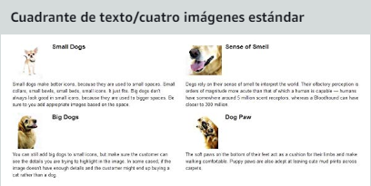
4 key art images 220:220 + 4 key features
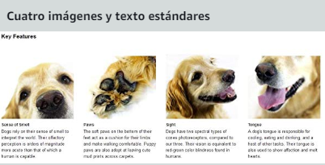
1 key art image 300:400 + 1 key art image 350:175 + 2 pharagraphs plot + text about product
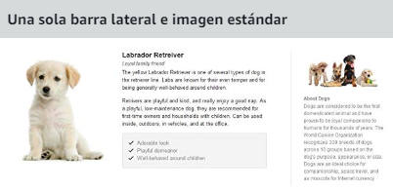

1 key art image 300:300 + key features
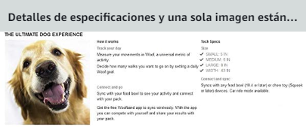
2 key art image 970:600 + key feature / game sinopsis
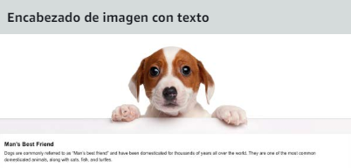
5 packshots 150:300
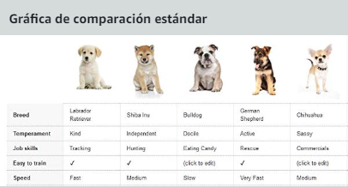
Logo image 600x180
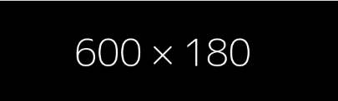

4 key art image 300:300 + game sinopsis
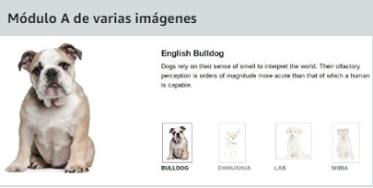
3 key art image 300:300 + 3 key features
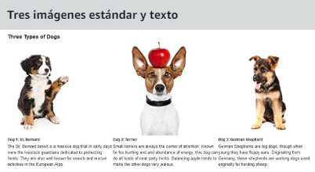
1 key art image 300:300 + game sinopsis / key feature
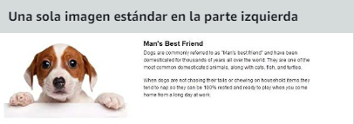
1 key art image 300:300 + game sinopsis / keyfeature
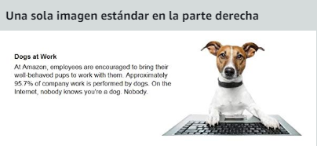
1 key art image 300:300 + game sinopsis / key feature


2 Keyarts 1920x1080
